APP SERVER AND WEB SERVER

INSTALL NGINX AND RUN NGINX ON PORT NUMBER 81

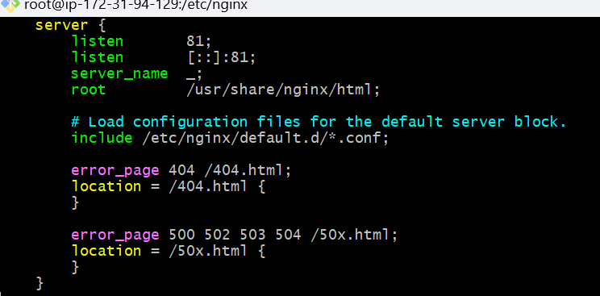

DEPLOY A SAMPLE INDEX.HTML FILE ON NGINX

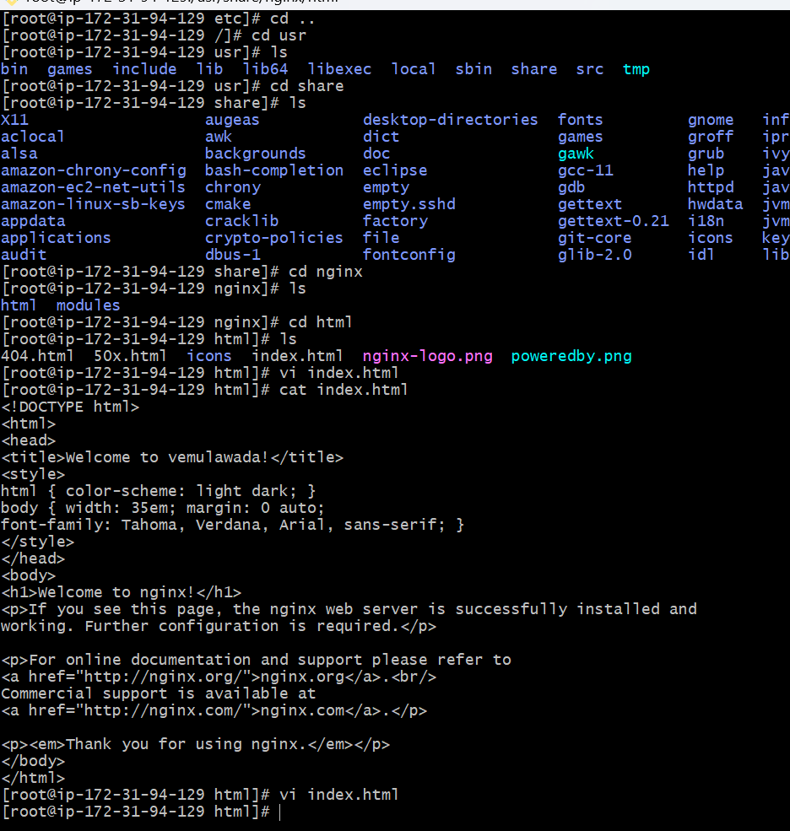

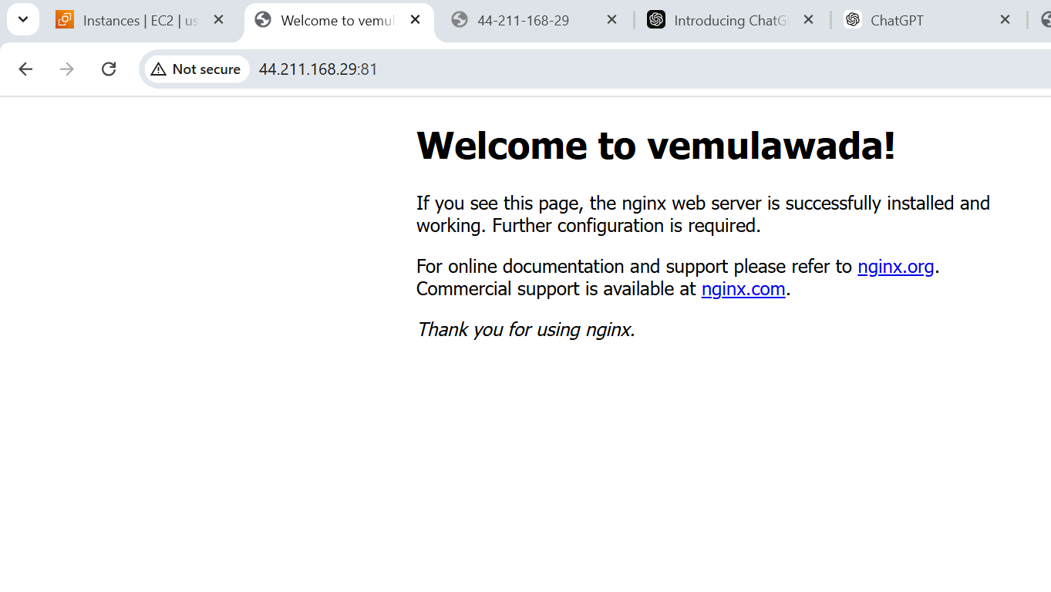

INSTALL APACHE AND RUN APACHE ON PORT NUMBER 82

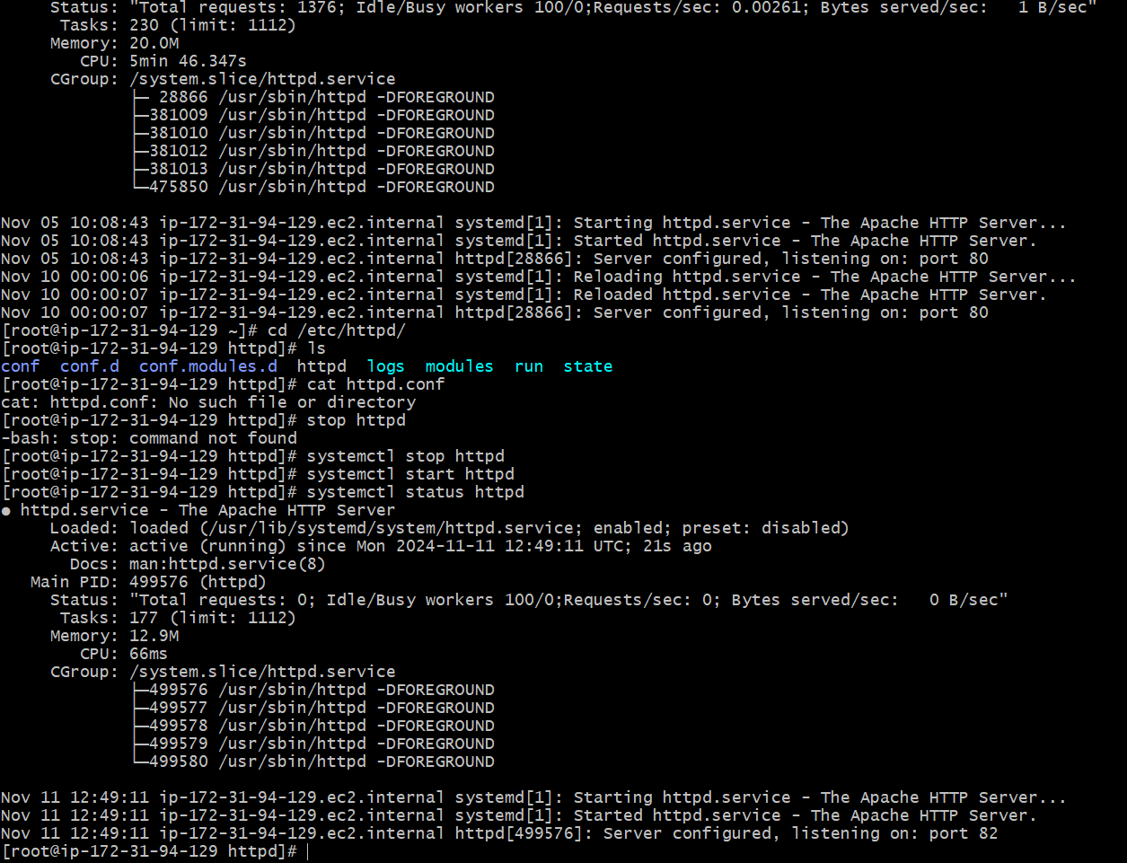

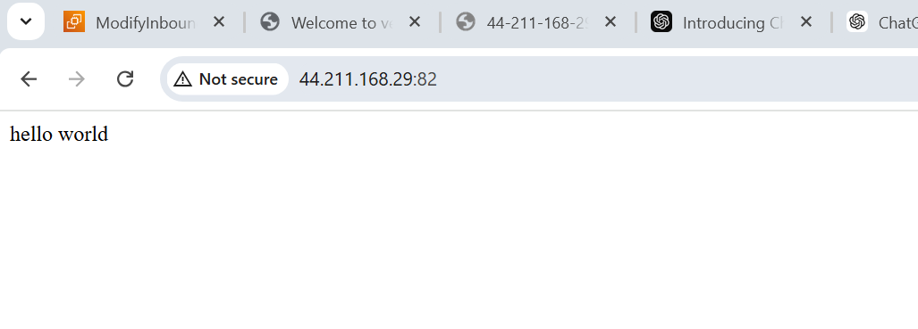

DEPLOY A SAMPLE INDEX.HTML FILES ON APACHE

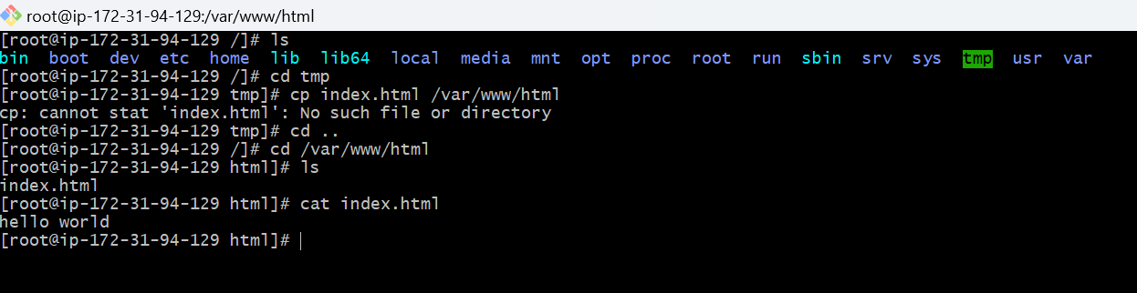

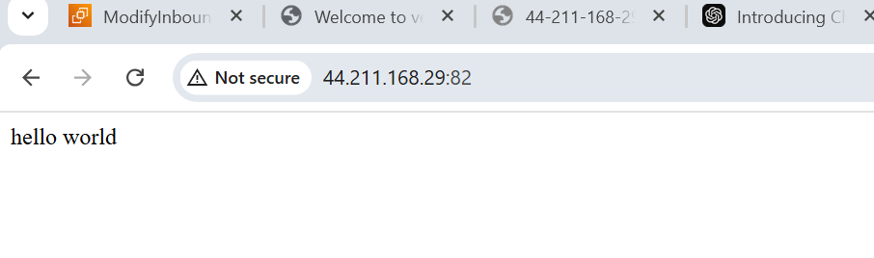

INSTALL APACHE TOMCAT ON PORT NUMBER 8082

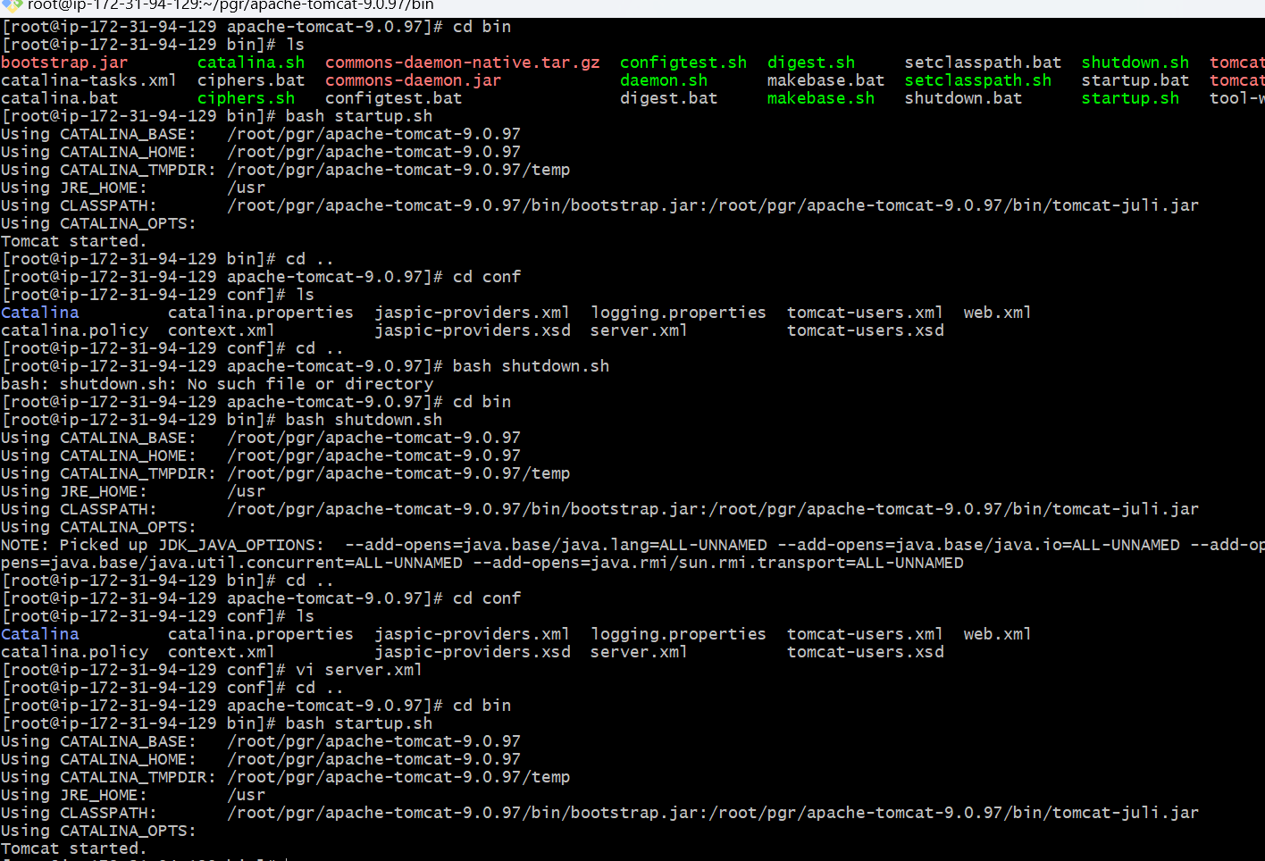

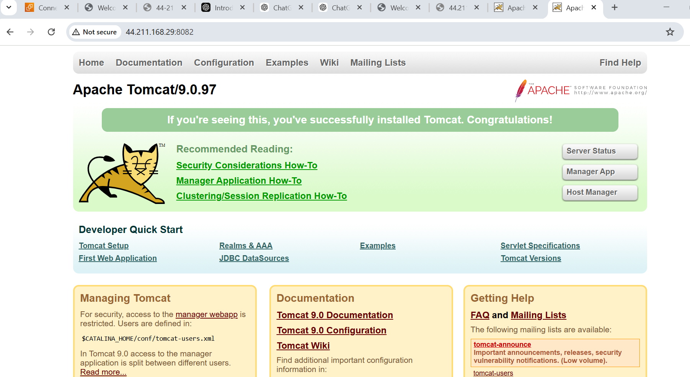

DEPLOY A SAMPLE APP ON WEBAPPS

